Full name: Lê Thành Đạt

ID student: 21IT063

Midterm Cross-platform applications report

CRUD app

Tech stack: React Native + MongoDB

**8/10/2024**: Init project, read docs about React Native: Core components…

**9/10/2024:**

+ Read docs and build basic sign in, sign up interfaces

+ Build backend using NodeJS. 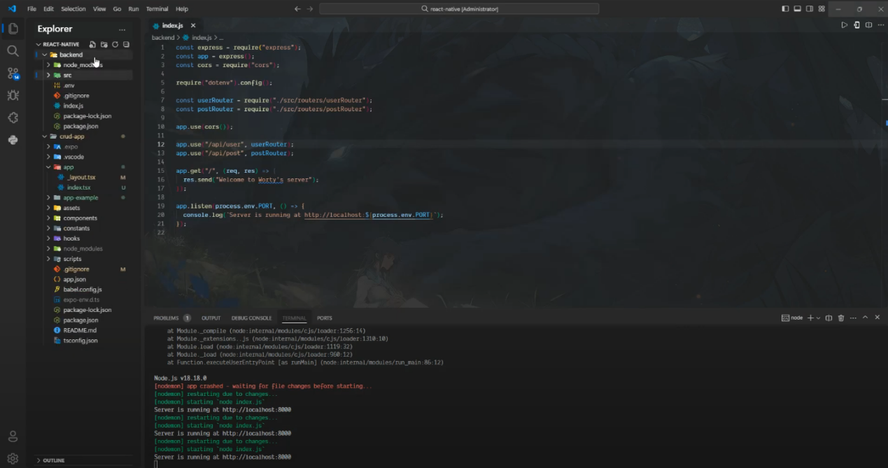

+ Allow users to sign in, sign up

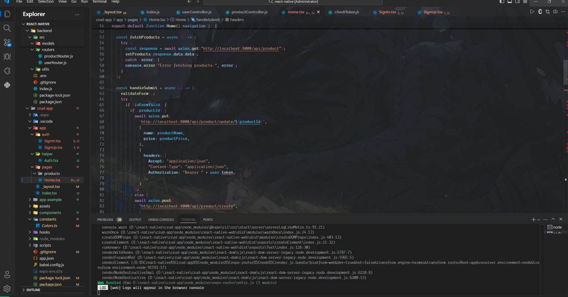

+ Handle authorization with jsonwebtoken

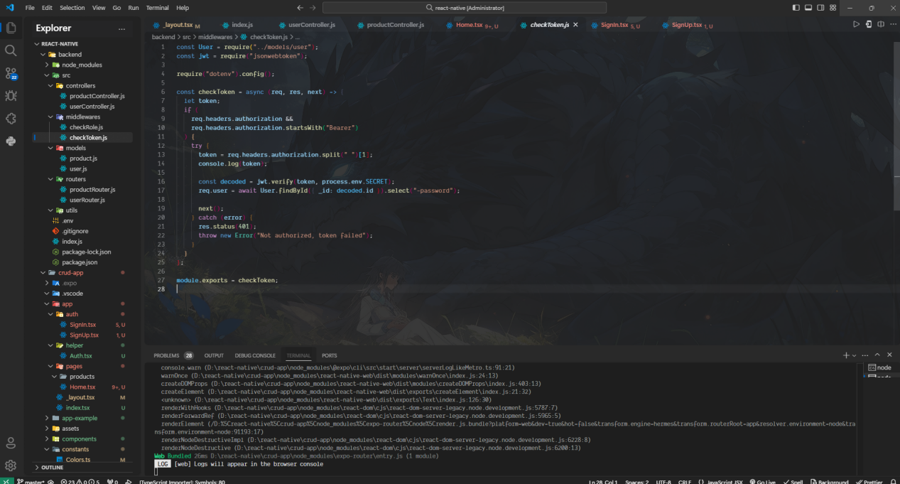

+ Add CRUD functions

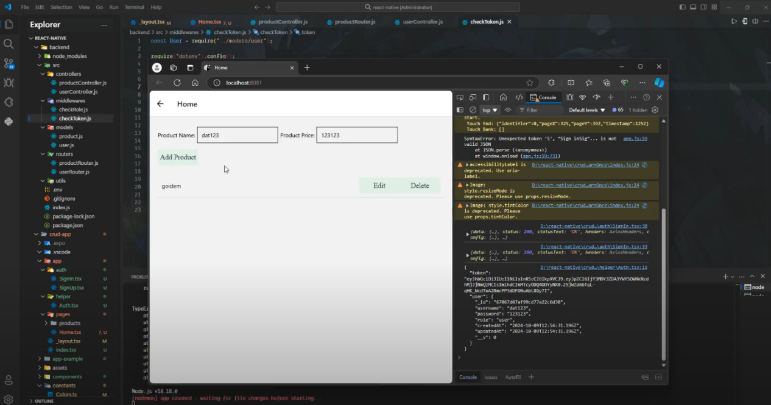

+ There are 2 roles: User and Admin, User: only see products and search products. Admin: CRUD, search.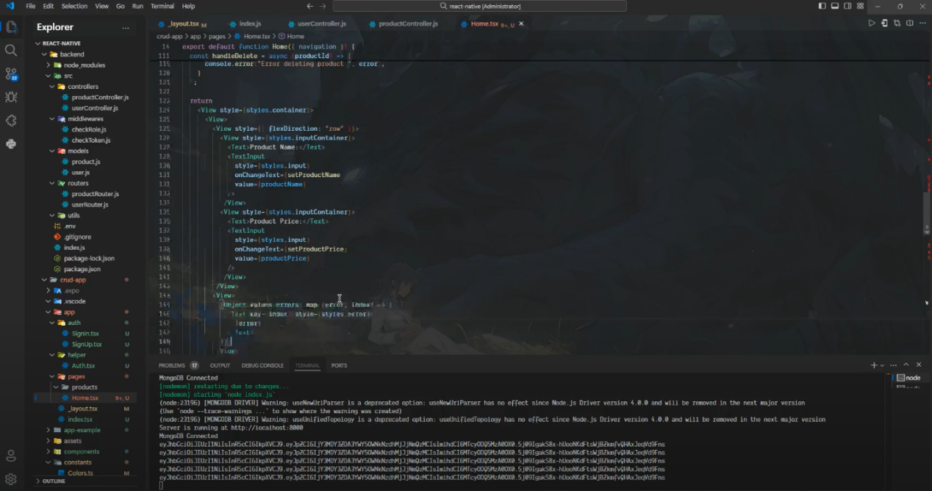

**10/10/2024:**

+ Authorize the user’s role whenever they do an action.

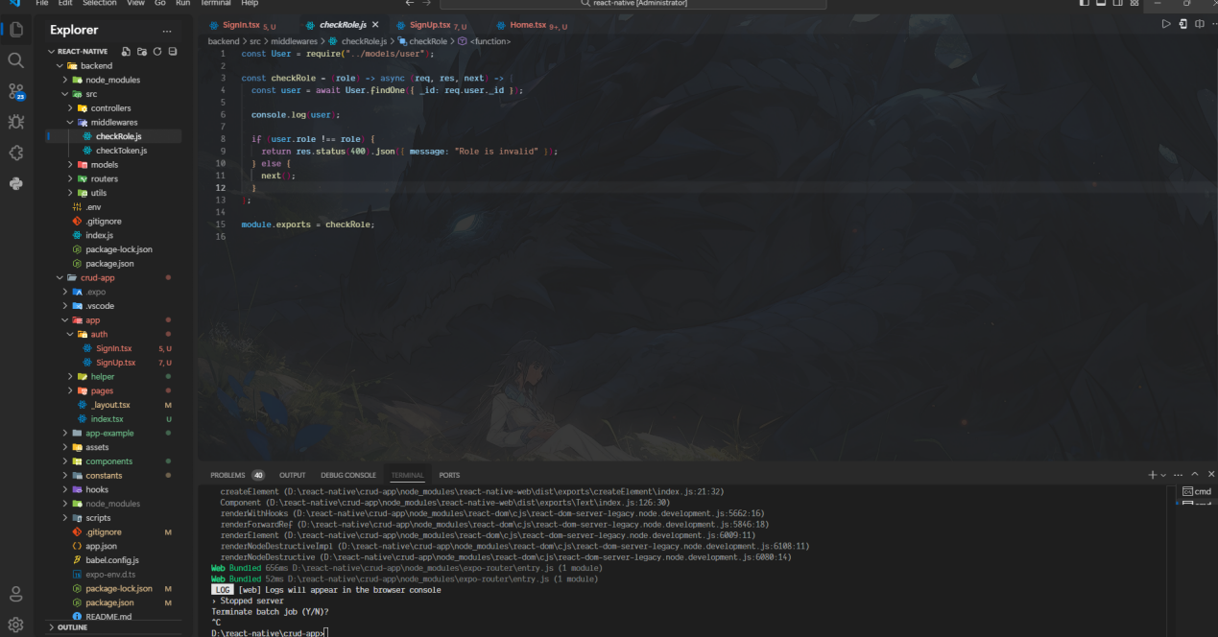

+ Upload image with Cloudinary

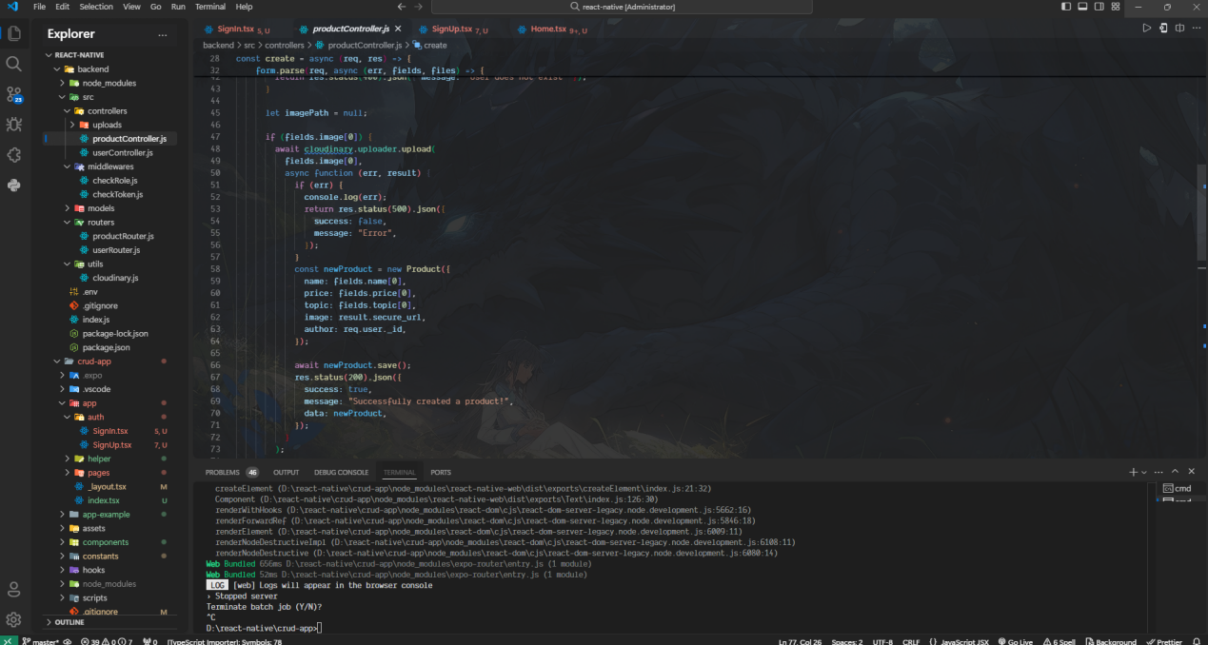

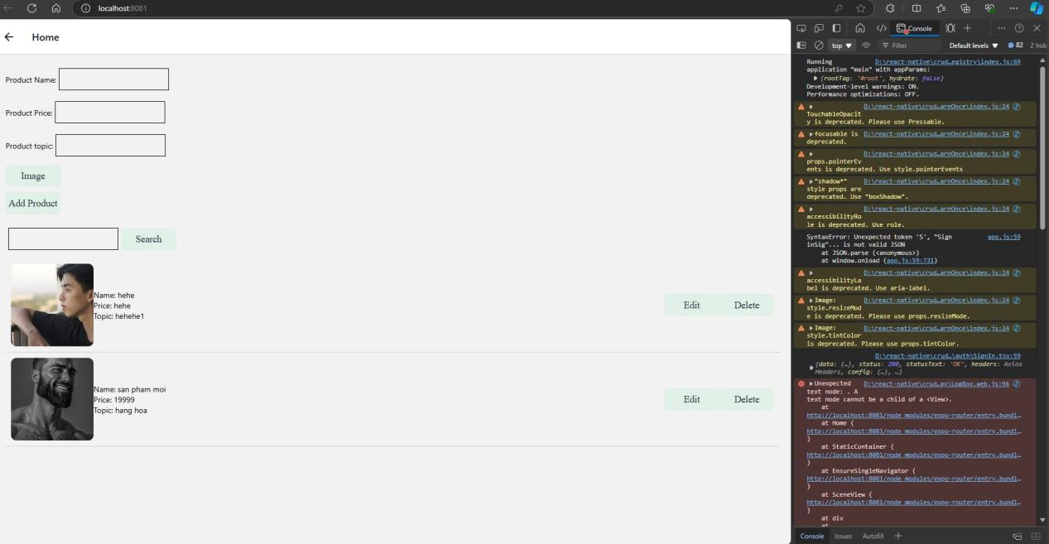

+ Allow to search products with name

+ Validate inputs (Sign in, Sign up, Create, Update)

  const validateForm = () => {

    let errors = {};

    if (!productName) {

      errors.productName = "productName is required.";

    }

    if (!productPrice) {

      errors.productPrice = "productPrice is required.";

    }

    if (!productTopic) {

      errors.productTopic = "productTopic is required.";

    }

    setErrors(errors);

    setIsFormValid(Object.keys(errors).length === 0);

  };

+ Handle the user’s token.

  async isAuthenticated() {

    const token = await AsyncStorage.getItem("token");

    const user = await AsyncStorage.getItem("user");

    if (!token) return false;

    let data = {

      token: token,

      user: user ? JSON.parse(user) : null,

    };

    return data;

  },

Github:

https://github.com/Worty76/react-native-crud

Videos: https://drive.google.com/drive/folders/1GRUXKjeJXaCZ6X7PYmBwUy2wGFGe1_wN?usp=sharing